Welcome to Proteine Plus - Your Personal Calorie and Exercise Tracker!

Thank you for choosing Proteine Plus to help you achieve your health and fitness goals. This user instruction document will guide you through the features and functionalities of our calorie tracking app.

Table of Contents:

# 1. Getting Started

- Account Creation/Login

# 2. Dashboard Overview

- Quick Access Buttons

# 3. Logging Meals

- Add Food Items

- Meal Timestamps

# 4. Exercise Logging

- Log Workouts

# 5. Easy Recipes

-Follow Along!

# 6. Basic Workouts

-Somewhere to start

# 7. Emulator Settings

-How to set up your emulator

# 8. Tips for Success

- Stay Consistent

- Set Realistic Goals

- Use the App's Resources

Getting Started

* 1. Account Creation

- Sign up using a Username and a secure password.

1.2 Account Login

-Login Using your username and password

Dashboard Overview

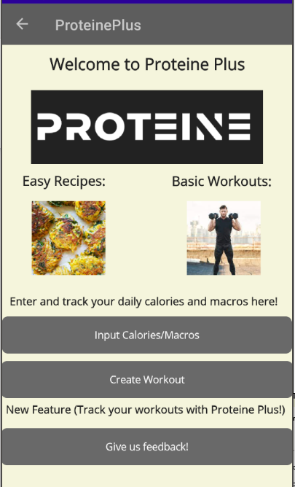

- Quick links to the resources Proteine Plus provides

(Calorie Tracking, Exercise Tracking, Meals, Exercises)

Logging Meals

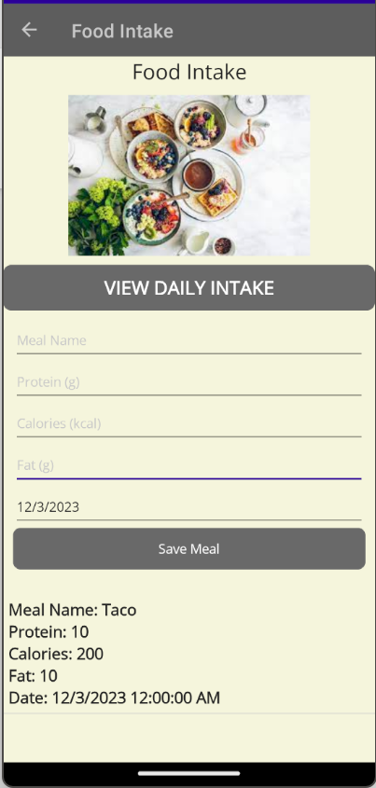

- Daily Calorie Summary

- View your daily calorie intake goal and complete log of all meals.

3.1 Add Food Items

- Add your meal name, calories, protein, and fat intake

- Select the appropriate portion size.

- Add to your daily log.

3.2 Meal Timestamps

- Log meals at the time of consumption for accurate tracking.

Exercise Logging

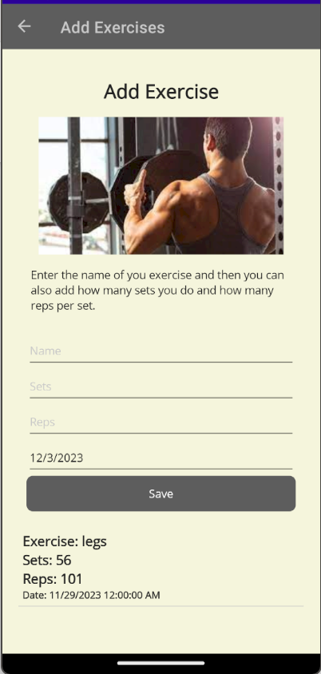

- Add your exercises manually using the Exercise name, Sets, Reps when you complete the workout.

4.1 Exercise Timestamps

- Log Exercises at the time of Workout for accurate tracking.

4.2 View Progress Over Time

- View your workout logs to see your progress

Easy Recipes

- Our Easy recipes feature helps you jumpstart your macro tracking adventure

-View the template meals and make them for yourself

Basic Workouts

- Our Easy Workout feature helps you with your workout lifestyle

-View the template workouts and customize them to your desire

Emulator Settings

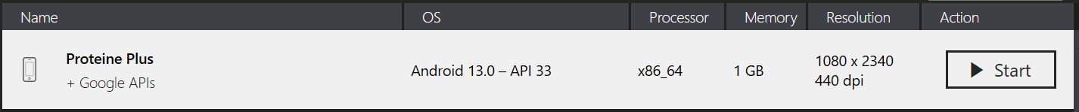

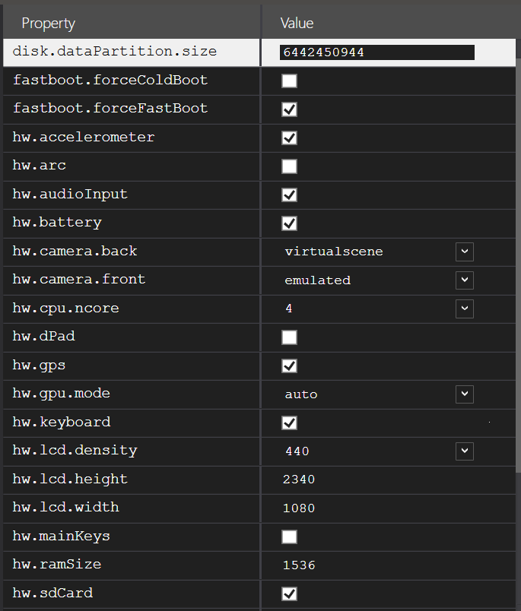

When using an emulator, Proteine Plus recommends you use our emulator settings. Above you can find all the settings that the developers have used and optimized Proteine Plus to run on.

Tips for Success

8.1 Stay Consistent

- Log meals and activities consistently for accurate results.

8.2 Set Realistic Goals

- Establish achievable targets for a sustainable and healthy journey.

Congratulations! You are now ready to make the most out of Proteine Plus. Happy tracking!